Setting Up Your Voicemail Preferences
If you are wanting to setup your voicemail mail to forward using the “Reach Me” or notify you when you have a voicemail using the “notify Me” feature remotely, the following instructions will help you get started.
- In a web browser, navigate to https://aam.usc.edu/user to log into your mailbox preferences
- On the log in screen, use your office line extension and voicemail password
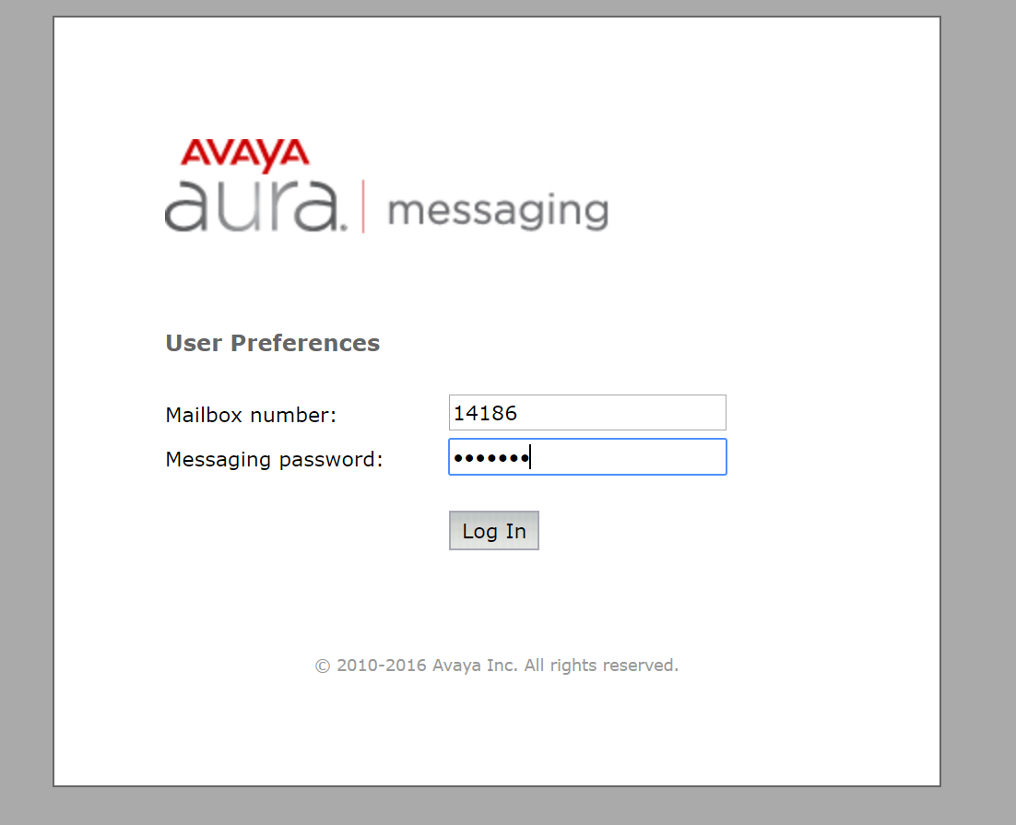
- From the “General Tab”, you can add a mobile phone for the “Notify Me” feature by entering it from the “Mobile Phone or Pager” section. *Don’t forget to click “Save”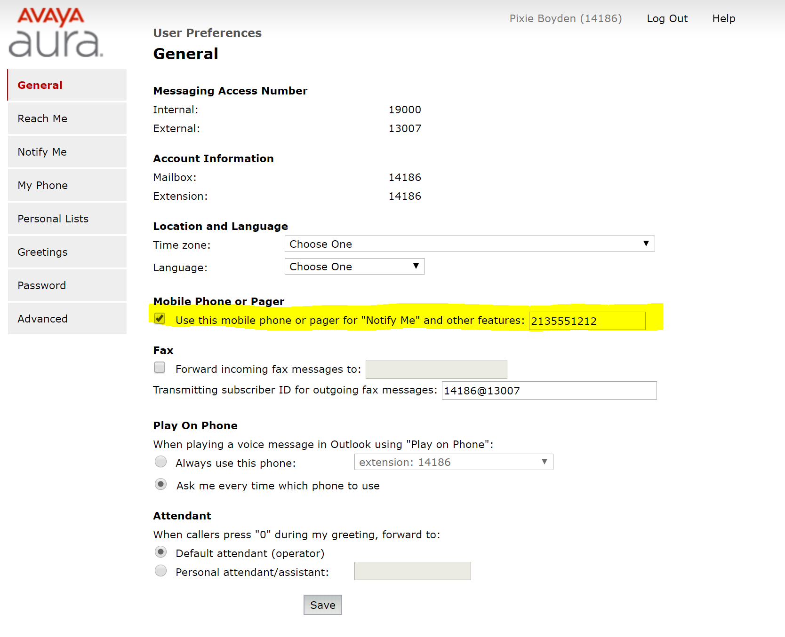

- To turn on the “Notify Me” feature, click the “Notify Me” tab to the left to reach the page, check the checkbox to turn on the feature (phone or email), set your desired preference, and click “save” before leaving the page.

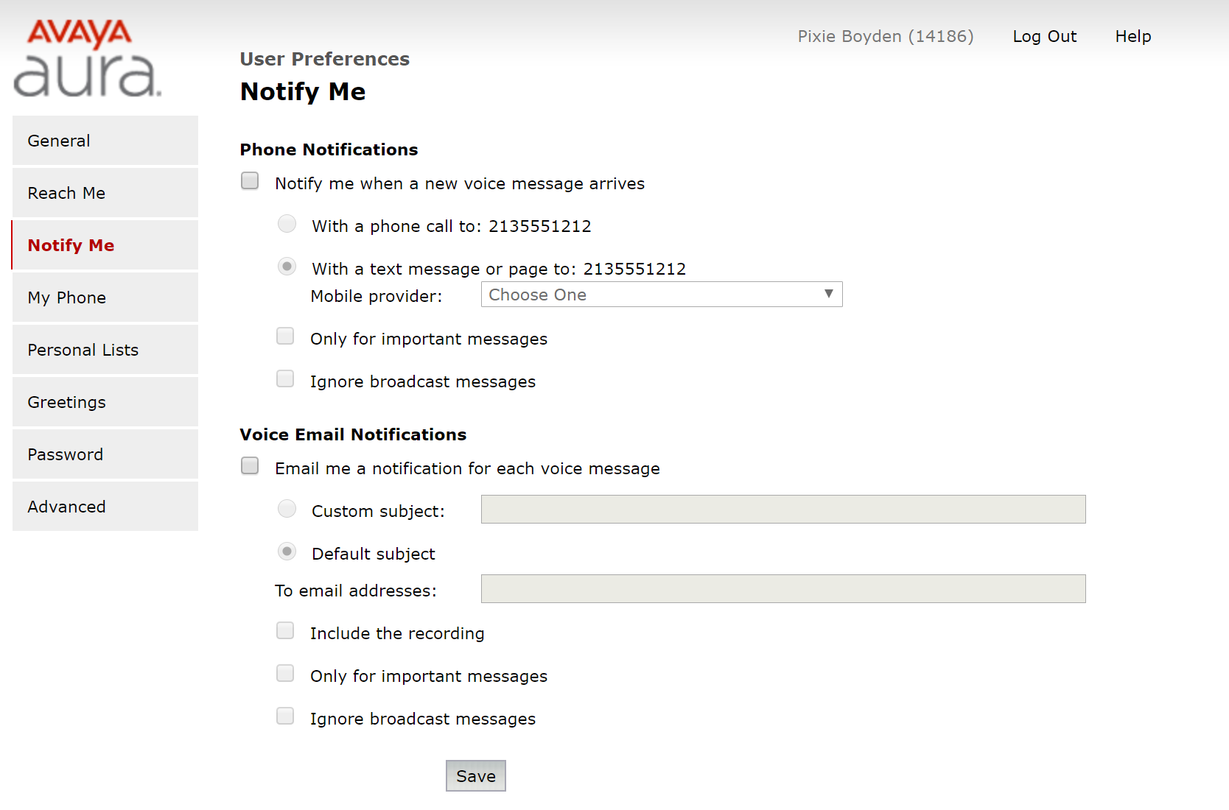
- To turn on the “Reach Me” feature, click on the “Reach Me” tab to the left to reach the page, click the checkboxes to configure the desired preferences, and click “save” before leaving the page. *You can add up to 3 numbers in daisy chain order if you are configuring departmental main lines if needed and set a business day schedule as well.
